Political Cartoons as Historical Evidence

Mara Joseph

Caribbean History 1900 to the Present
AFPRL 21000
Roberta Walker Kilkenny

02/25 /19
Political Cartoons as Historical Evidence

Before you answer the questions examine the cartoon below and think about the following: What do you see in it? What do you think the artist was trying to say? Review the coursework and do any additional background reading you feel will help you to better understand the cartoon. Look over the Cartoon Analysis Checklist.

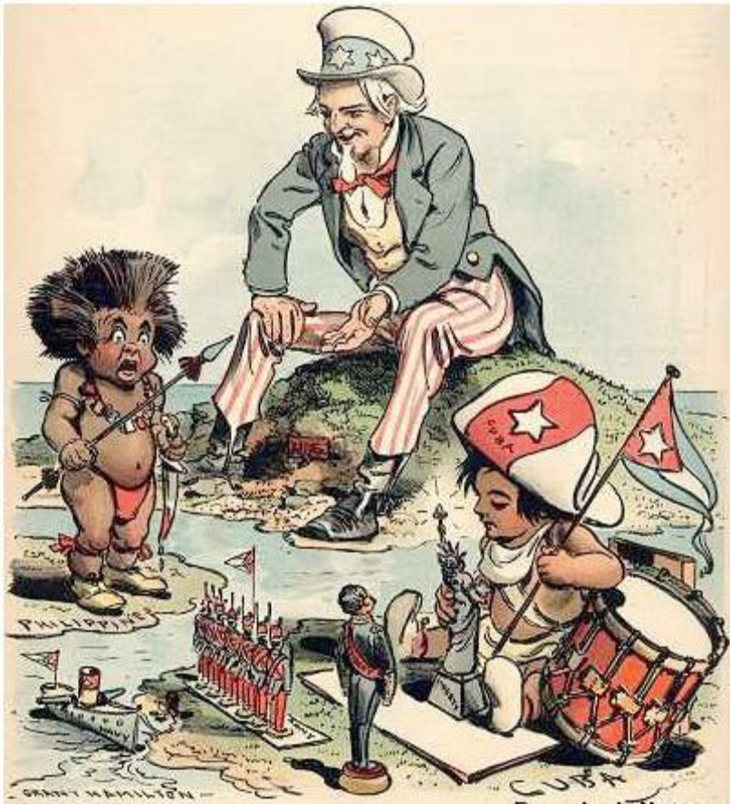

Artist: Grant Hamilton
Magazine: Judge, New York, December 14, 1902

Caption: “Now, Will You Be Good? Uncle Sam (to Filipino) — "See what I do for a good little boy?"

Questions
Answer each question briefly. Just use a few sentences, but be specific. “Yes” or “no” answers or generalizations are not satisfactory. You must provide evidence to support your responses. Use Chicago Style endnotes or footnotes to credit any sources you use. A bibliography is not necessary.
- What was happening in the United States when this cartoon was created that is relevant to your understanding of the cartoon?

- What was happening in the Caribbean when this cartoon was created that is relevant to your understanding of the cartoon?

- In some of the political cartoons included in our coursework the United States was depicted as a woman named Colombia or Lady Liberty. What did those depictions of Colombia or Lady Liberty suggest about the United States? (Include the title of the cartoon from our coursework that you are analyzing.)

- Comparing your analysis of Colombia or Lady Liberty in Question 3 with cartoonist Grant Hamilton’s depiction of the United States as Uncle Sam in “Now, Will You Be Good?” do you get a different ‘feeling’ about the United States in “Now, Will You Be Good?” Why or why not?

- Not including Uncle Sam, what people are depicted in Hamilton’s “Now, Will You Be Good?” What does the use of stereotypes or caricatures suggest about the people being depicted?

- What objects are depicted in “Now, Will You Be Good?” What do the objects symbolize?

- Describe the actions taking place in this cartoon. What do the actions symbolize?

- What attitudes about United States’ imperialism does this cartoon convey?

- Who was the intended audience for Judge magazine?

- Describe any biases reflected in the cartoon. Do these biases still exist in the United States today?

